Software Testing Question 1

ITF (Independent Testable Functions)

We are going to test the method toRelativeURL. This will be our independently testable function (ITF), since we are unit testing this is the smallest granularity of test.

The URL objects in the ITF are defined by the Java API as a pointer to a resource on the world-wide web where a resource could be either a file, directory or a query. It should be noted that this is not the same as a URL as defined by RFC 3986.

The method being tested accepts two URLs, a base and a target. It then finds a URL relative to the base which when combined, with the base, resolves to the target. The following are examples:

Base URL: file://a/  Target URL: file://a/b/c/  Relative URL: b/c/ | Base URL: file://a/b/c/  Target URL: file://a/d/e/  Relative URL: ../../d/e/
Base URL: file://a/  Target URL: file://a/  Relative URL: ./ | Base URL: file://a/b/  Target URL: file://c/d/  Relative URL: file://c/d/

Parameters and Environment Elements

The parameters for this method are the two URLs which we supply. The environment characteristics are the operating system, Java Development Kit (JDK) and hardware (memory, CPU etc.). The operating system is a key environment characteristic as a key difference between Unix and Windows operating systems is the direction of the slash in URLs. We can disregard this for testing purposes though since Java’s URL object parses the URL for us. The JDK could effect the output but we have confirmed that all Java objects and methods were available from JDK 1.0, so we can disregard this also. The hardware in a modern computer is easily able to perform all actions required by the function, thus we will also disregard this.

Characteristics for each of our two input URLs include:
- Differing protocol
- Differing host
- Number of folders
- Target and base folder structures
- Has a file or not
- Has query string
- Has fragment

Partitions for the Parameters and Environments
These then generate the following partitions:
- Differing protocol - yes or no
- Differing host - yes or no
- Number of base folders - zero, one, many
- Number of target folders - zero, one, many
- Target and base folder structures - yes or no
- Base has a file or not - yes or no
- Target has a file or not - yes or no
- Base has query string - yes or no
- Target has query string - yes or no
- Base has fragment - yes or no
- Target has fragment - yes or no

Using these partitions we can generate value classes:
- Differing protocol - true or false
- Differing host - true or false
- Number of base folders - 0, 1, >1
- Number of target folders - 0, 1, >1
- Target and base folder structures - true or false
- Base has a file or not - true or false
- Target has a file or not - true or false
- Base has query string - true or false
- Target has query string - true or false
- Base has fragment - true or false
- Target has fragment - true or false
This gives us 4068 tests.

Constraints

Finally we apply constraints to our partitions:

- Differing protocol - [single]
- Differing host - [single]
- Number of base folders - 0 [property SS], 1 [property BNSS], >1 [property BNSS]
- Number of target folders - 0[property SS], 1 if [property TNSS], >1 [property TNSS]
- Target and base folder structures - true or false [if BNSS and TNSS]
- Base has a file or not - [single]
- Target has a file or not - [single]
- Base has query string - [single]
- Target has query string - [single]
- Base has fragment - [single]
- Target has fragment - [single]

BNSS - Base Not Same Structure
TNSS - Target Not Same Structure

We decided on these constraints for the following reasons:

- For singles we believe that a single test verifies that it will cover further scenarios
- For different folder structure we do not consider zero folders as there is nothing to compare between the base and target URL

This gives us 8 + 3*3 + 2*2 = 21

Some of these test cases can be deleted to reduce our test suite as we feel that these cases are already covered by previous tests. The tests that were deleted are as follows:

- Same Folder Structure - One Folder for Base, One Folder for Target
- Same Folder Structure - Two Folder to Base , Two Folders to Target

Our new test suite consists

21 - 2 = 19 tests

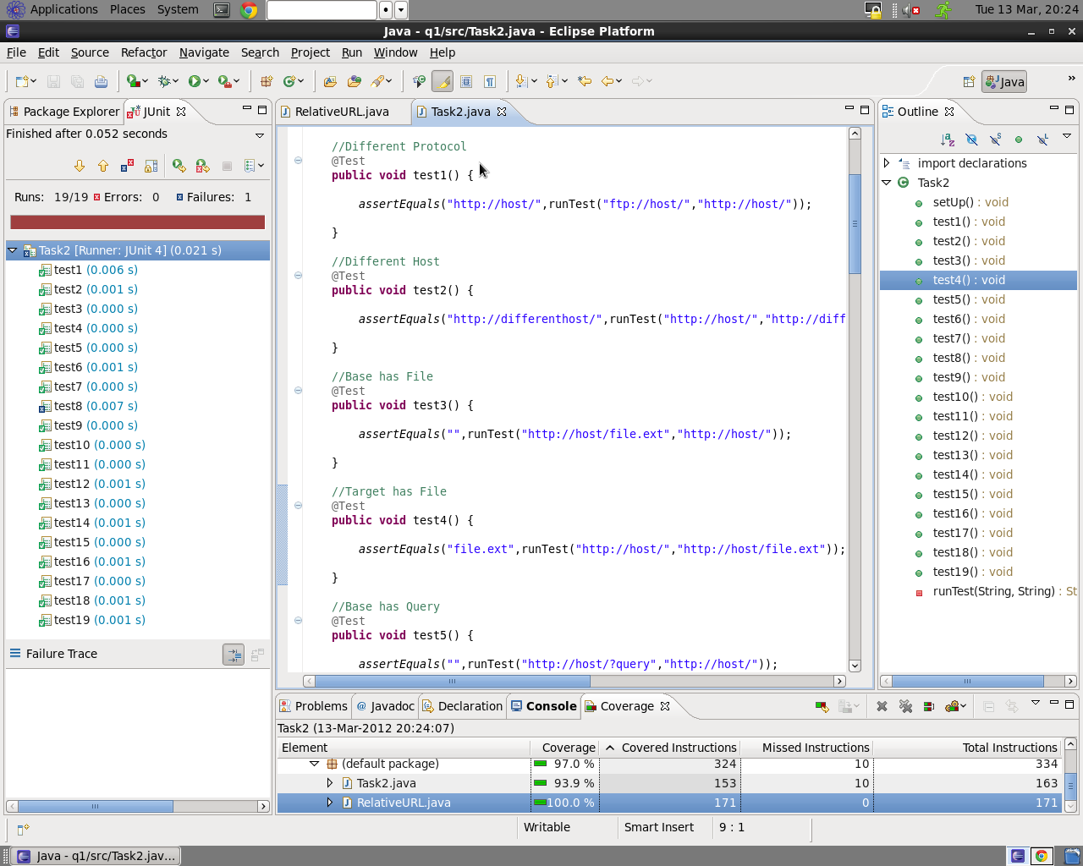

With this test suite we achieved 100% coverage according ECLemma.

We encountered a fault with test 8 - it did not return the result we expected. This is a result of Java’s URL.getFile() method removing fragments, despite being a valid part of the URL (RFCA 3986). To fix this, we changed the final two references of URL.getFile() to URL.toString(). That way, whenever we appended the end (the file or query string typically) to the relativeURL, toString() does not remove fragments like getFile() does.

